Chapter 2: The Port of Grønnfjord
The salt-tinged air carries the sounds of creaking masts and merchant haggling as your ship docks at Grønnfjord's bustling harbor. The town spreads before you like an amphitheater carved into the fjord's steep walls, with wooden buildings climbing the rocky slopes in terraced layers. At the town's crown sits an imposing new structure - a gleaming temple of grey stone that seems almost alien against the weathered timber and slate of the older buildings.

Arrival and First Impressions
As the party disembarks, they immediately notice the contrast between old and new in Grønnfjord. The harbor bustles with typical Nordic activity - fishermen mending nets, merchants hawking wares, and longshoremen hauling cargo. But there's an underlying tension in the air, and conversations seem to die when certain topics arise.
Read to the players: The first thing that strikes you about Grønnfjord isn't the impressive harbor or the terraced buildings climbing the fjord walls - it's the silence that falls over groups of people when they notice strangers. Merchants smile and welcome you, but their eyes dart frequently toward the temple crowning the town. You catch fragments of whispered conversations: "Jak's Peace," "the Spásistren," and "since the temple awakened"

The Harbor District - Outfitting

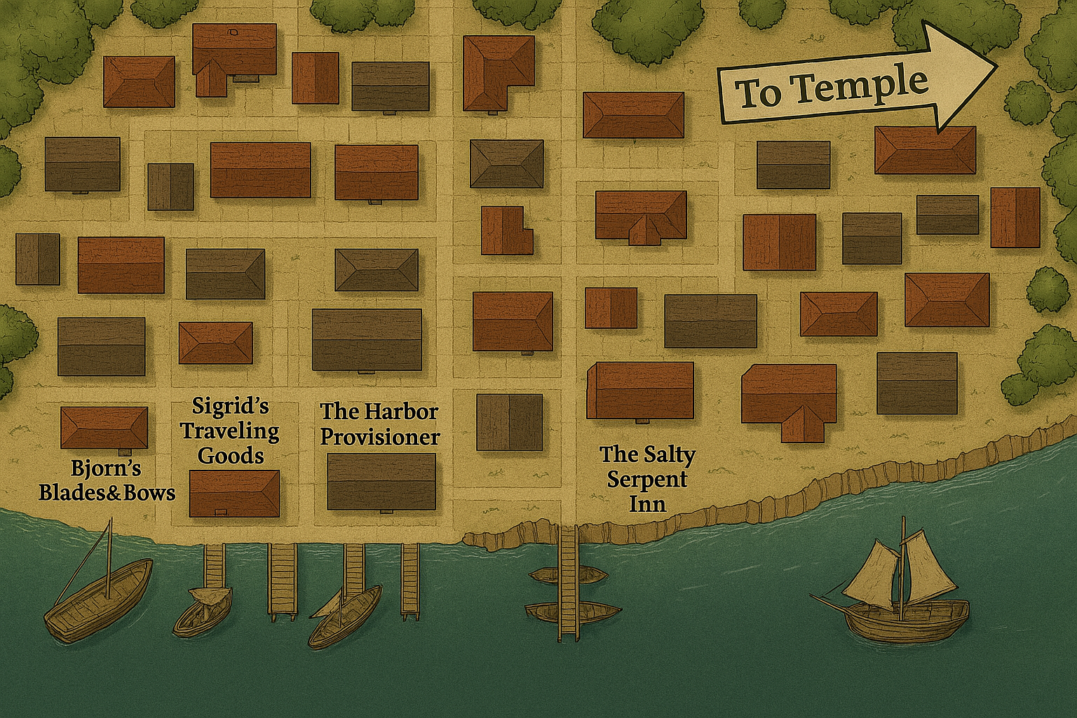

Bjorn's Blades & Bows
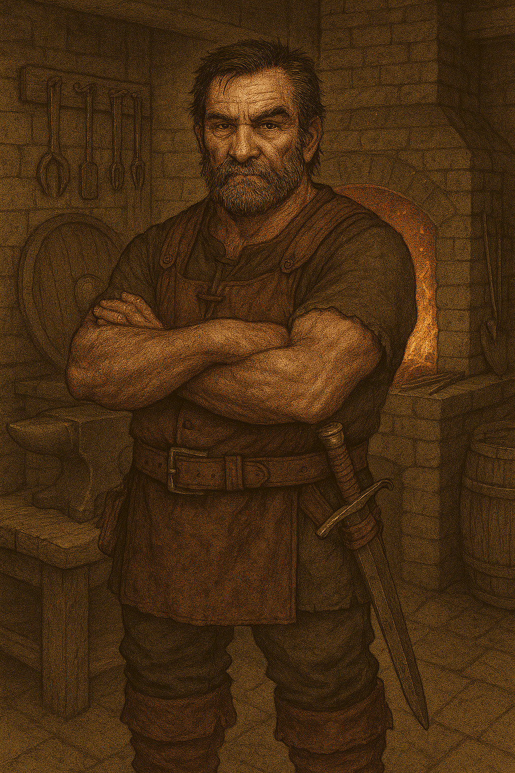
A weathered wooden shop with weapons displayed in the windows. The sound of hammer on anvil rings from the back.
Bjorn Ironhand (Human Male, 45) - A gruff weaponsmith with scarred hands and a permanent scowl. He has quality weapons but speaks in hushed tones about current affairs.
"Aye, I've got what you need. Good steel, honest work. Just... mind yourselves in town, eh? Those fancy temple folk don't take kindly to trouble-makers. Not that I'm saying you'd cause trouble, but..." he glances toward the temple "Things have changed since they arrived."
Available Gear: All standard weapons and armor at normal prices. Bjorn will quietly mention that the Spásistren "don't carry steel - don't need to, from what I've seen."

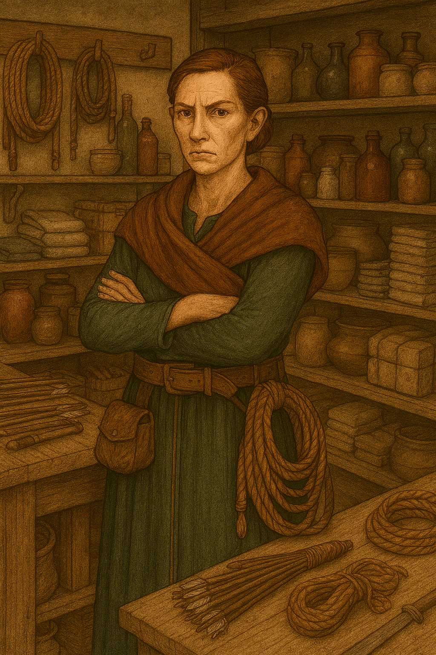
Sigrid's Traveling Goods
A well-organized general store with goods neatly arranged on wooden shelves. The proprietor watches customers carefully.
Sigrid the Sharp (Human Female, 38) - A keen-eyed merchant who's adapted to the new order but remembers the old ways.
"Welcome to Grønnfjord, travelers. I have everything you need for the road ahead. Rope, rations, torches, camping gear... Business has been... different since the temple’s been occupied. More travelers, more trade. Some say it's prosperity. Others..." she shrugs noncommittally
Available Gear: All standard adventuring supplies, equipment, and traveling gear at normal prices.

The Harbor Provisioner
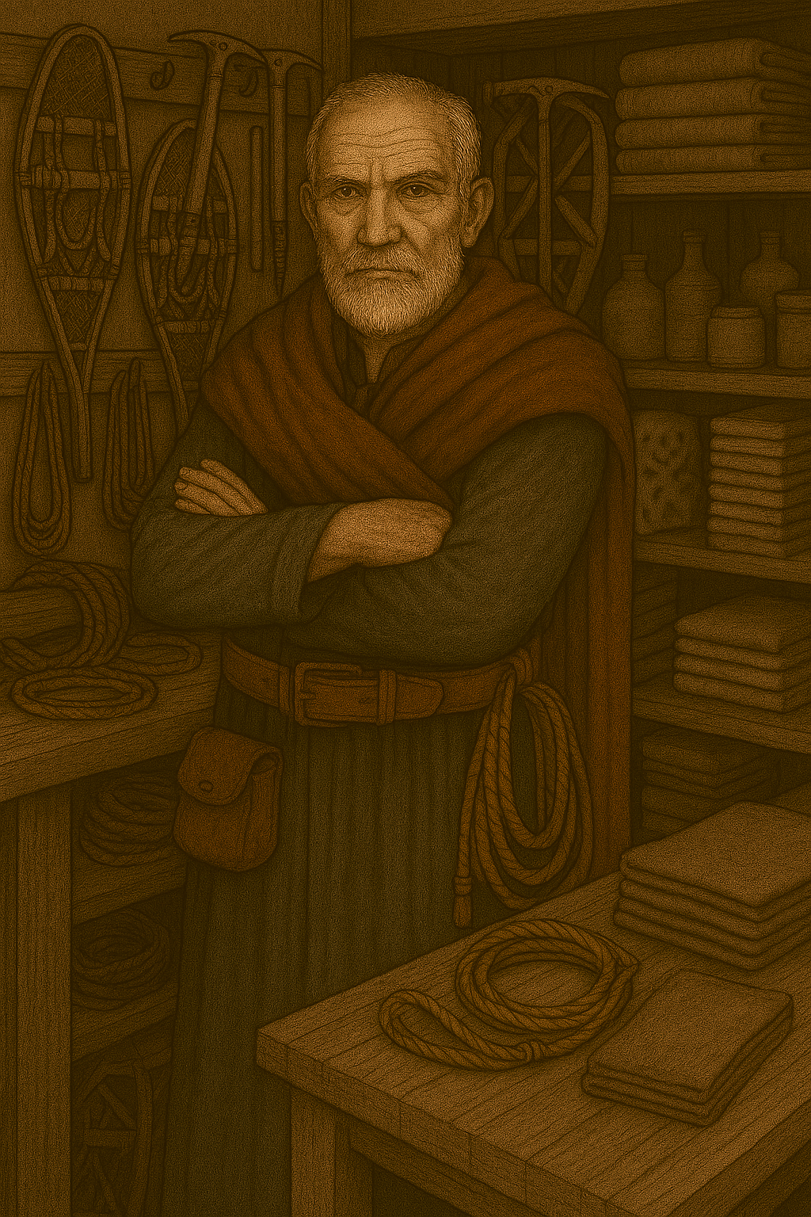
A smaller shop specializing in clothing and weather gear. The elderly proprietor seems more willing to speak his mind.
Erik the Elder (Human Male, 62) - A longtime resident who's seen many changes in Grønnfjord, but none like this.
"Boots, cloaks, anything to keep the northern weather from your bones. Been outfitting travelers for thirty years, I have. Used to be a man could speak his mind in Grønnfjord. Now those blue-glowing women are always watching, always listening." he lowers his voice "Mark my words - there's more to Jak's Peace than meets the eye."
Available Gear: Cold weather clothing, boots, cloaks, bedrolls, and survival gear.

The Salty Serpent Inn
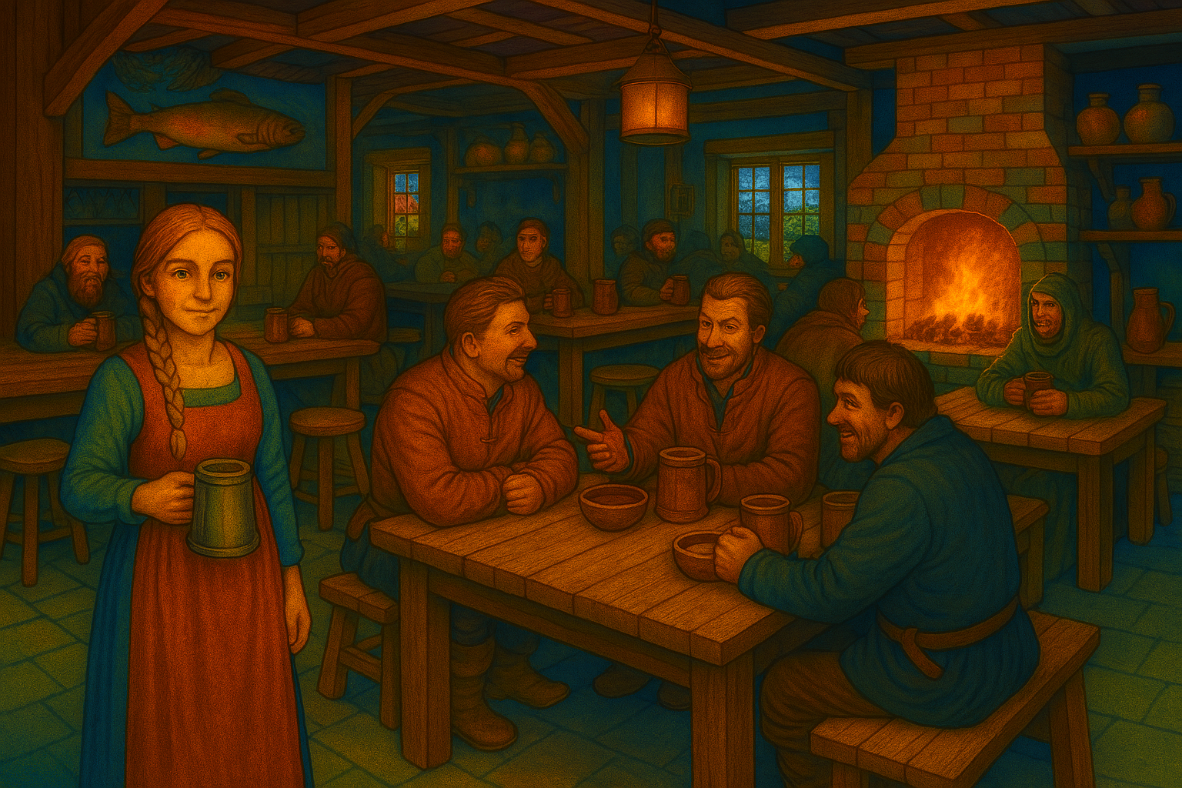This three-story timber inn sits at the convergence of the harbor road and the path leading up to the temple. The common room buzzes with conversation that quiets when sensitive topics arise.
The inn serves as the information hub of this chapter. The party can gather rumors, witness the divided opinions about Jak's rule, and potentially encounter Spásistren.
Lodging Prices:
- Shared room: 2 silver per night
- Private room: 5 silver per night
- Meals: Fish stew, dark bread, and local ale for 3 copper
As the party steps inside the Salty Serpent Inn, the scent of fish stew and dark bread mingles with the salt air drifting in from the harbor. The common room is spacious, built from sturdy timber, with beams overhead and lanterns casting a warm, golden glow across the bustling crowd. Long tables are filled with sailors, traders, and townsfolk, their conversations a lively hum—until sensitive topics arise, when voices drop and eyes flick toward the temple up the hill.
At the bar, a weathered sailor nurses his ale, hands trembling as he speaks quietly to anyone who’ll listen about the dangers of the southern waters. A friendly barmaid moves between tables, her braided hair swinging as she serves drinks and exchanges cautious smiles with newcomers. The walls are adorned with faded nautical charts, fishing nets, and carved wooden figures of sea creatures.
The party quickly realizes this is more than just a place to eat and sleep—it’s the information hub of Grønnfjord. Rumors swirl about Jak’s rule, the mysterious Spásistren, and strange happenings in the Barrier Peaks. Some patrons seem eager to share tales of prosperity and safety, while others glance nervously at the door, wary of who might be listening.
As the adventurers settle in, they sense the tension beneath the surface—Grønnfjord is a town divided, and the Salty Serpent is where secrets and stories come to light.

Key NPCs
Astrid the Barmaid (Human Female, 24) A friendly young woman with braided blonde hair who's lived in Grønnfjord her entire life. She serves drinks with a smile but speaks carefully about current events.
"The temple's been here two years now. Changed everything, it has. Some say for the better - no more clan raids, trade is booming, children are safe to play in the streets. Others..." she glances around nervously "Others say the price is too high."
If asked about the Spásistren: "Beautiful, they are. And deadly. All women, they say Jak only trusts women to guard him. They don't carry swords or axes like the old warriors - don't need to. I saw one of them stop a brawl between three drunk sailors just by touching pressure points on their necks. Dropped them like sacks of grain, she did. And those... things behind their ears. Metal rings that glow soft blue sometimes. Gives me the shivers."

Captain Olaf Stormsson (Human Male, 53) A weathered sailor with gray-streaked beard and eyes like storm clouds. He drinks alone at the bar, nursing his ale while studying newcomers. His hands shake slightly when he speaks of the southern waters.
"I've sailed all the northern seas for thirty years, and I've never seen anything like those Spásistren. They move like dancers, fight with nothing but their bare hands and feet, and can drop a man twice their size without breaking a sweat. And their eyes... it's like they're seeing something you're not. Hearing voices we can't hear." He takes a long drink "But that's nothing compared to what's happening in the Barrier Peaks. Lost two good ships trying to get close to that southern coast. The crews that made it back... they speak of things in the water that ain't fish, ain't whale, ain't nothing natural. Metal gleaming beneath the waves, and sounds like machinery grinding in the deep."
Services: Can transport the party to various locations along the fjords for negotiated prices (50-100 gold depending on distance and danger). Refuses to sail within 20 miles of the Barrier Peaks coastal waters - "Not for all the gold in the nine realms."

Overheard Conversations
Roll 1d6 each time the party spends time in the common room. On a 4-6, they overhear one of these conversations:
1. Two Fishermen at the Bar: "I tell you, Magnus, those Spásistren gave me the chills when they walked past yesterday. Did you see that blue glow behind their ears?" "Aye, and the way they moved together... like they were listening to voices we couldn't hear. Unnatural, I say."
2. A Merchant Woman to Her Companion: "Jak's brought peace, I'll give him that. No more raids from the hill clans, no more feuding between the local lords. But at what cost? My daughter speaks of joining the Spásistren, and I've seen what happens to those girls... they come back different."
3. An Old Warrior: "'Jak's Peace' they call it. Peace for who? Those of us who remember the old ways, when the local lords ruled by strength and honor, not... whatever sorcery runs that temple. Mark my words - this peace won't last. It never does."
4. Young Couple Whispering: "Did you hear about the ships heading south toward the Barrier Peaks? Captain Erikson saw them - strange vessels carrying materials to someplace called 'Nordkrist's Hold.' What do you think they're building down there in those cursed mountains?" "Shh! You know we're not supposed to talk about such things. The Spásistren have ears everywhere."
5. Local Trader: "Business is good, can't deny that. Trade routes are safe, taxes are fair, and there's order in the streets. But sometimes I wake at night hearing strange sounds from the temple... humming, like machinery. What kind of god needs machinery? And those reports from the southern mountains - strange lights, terrible monsters that ain't natural..."
6. Worried Mother: "My Ingrid went for the temple ceremony last week - said she wanted 'Jak's blessing.' She came back speaking of visions and purpose. Now she stares at nothing for minutes at a time, like she's listening to something I can't hear. But worse are the stories from the Barrier Peaks - creatures like nothing the old tales described, metal and flesh twisted together..."
7. Frightened Shepherd (new): "I tell you, something's wrong in the southern peaks. Lost three of my best rams to... things that shouldn't exist. Creatures with too many eyes, skin like metal, moving in ways that hurt to watch. The few survivors who've made it back from those mountains speak of horrors beyond imagining. And the stench... like rotting meat mixed with hot metal."
8. Worried Father (new): "My son Erik was part of a group that went to investigate the strange lights in the Barrier Peaks three months ago. Seven brave souls, well-armed and experienced. None came back. The local lord sent another search party a month later - they found some torn equipment and... things... that used to be armor, but twisted like metal clay. No bodies, mind you. Just... remnants."

Encounter: The Spásistren
This encounter can occur at any time while the party is in town, but works best after they've gathered some information.
Read when the encounter begins: A hush falls over the street as two figures approach with measured, synchronized steps. The Spásistren move like water given form - tall, athletic women in flowing blue robes, their movements precise and graceful. Each carries a simple quarterstaff, but their empty hands seem more dangerous than any blade. Most striking are the small metallic rings visible behind their left ears, currently dormant but somehow ominous in their silence.
The Spásistren (use Monk statistics, 8th level):
- AC 16 (Unarmored Defense, Dex 18, Wis 16)
- HP 68 each (8d8 + 16)
- Speed 45 ft (Unarmored Movement)
- STR 14, DEX 18, CON 14, INT 12, WIS 16, CHA 10
- Proficiency Bonus +3
- Saving Throws: Str +5, Dex +9
- Skills: Acrobatics +9, Insight +6, Perception +6, Stealth +9
- Damage Immunities: Charmed, Frightened (due to aura implants)
- Attacks:
  - Multiattack: Two unarmed strikes or quarterstaff attacks
  - Unarmed Strike: +9 to hit, 1d6+4 bludgeoning damage
  - Quarterstaff: +9 to hit, 1d6+4 (one-handed) or 1d8+4 (two-handed)
- Ki Points: 8 points, recharge on short/long rest
- Special Abilities:
  - Stunning Strike (save DC 14)
  - Patient Defense, Step of the Wind, Flurry of Blows
  - Slow Fall (40 feet)
  - Extra Attack
  - Aura Network: Telepathic communication with other Spásistren within 1 mile and direct communication with Jak
  - Coordinated Strike: When fighting alongside another Spásistren, they can use a bonus action to grant advantage to the other's next attack
Behavior:
- They patrol in perfect synchronization, never speaking unless addressed
- If the implants activate (DM's choice for dramatic effect), they pulse with soft blue light
- They speak in measured, almost mechanical tones: "Citizens, maintain the peace. Jak protects. Jak provides."
- They're polite but intimidating, asking newcomers their business in town
- They don't start fights but will defend themselves with lethal efficiency if attacked
If approached peacefully: "Greetings, travelers. Welcome to Grønnfjord, seat of Jak's Peace. State your business and intentions. All who seek honest trade and peaceful passage are welcome under Jak's protection."

Information Gathering
By the end of their time in Grønnfjord, the party should learn:

About Jak:
- Unified the northern fjords under his rule two years ago
- Rules from a new temple of white stone
- Protected by an all-female guard called the Valkyries
- Brings "peace and prosperity" but at an unclear cost
- Ended the constant raids and feuding between local lords

About the Spásistren:
- All-female monks with mysterious technological implants
- The implants pulse blue when receiving orders/communication
- They move with perfect coordination and supernatural awareness
- Feared and respected by the townspeople
- Don't use traditional weapons, relying on martial arts

About the Divided Opinions:
- Younger people and merchants generally support the new order
- Older residents and traditionalists are suspicious or hostile
- Some families report children acting strangely after temple ceremonies
- Strange activities and sounds from the temple at night

About Nordkrist's Hold and the Barrier Peaks:
- A mysterious location in the southern Barrier Peaks mountain range
- Ships have been seen carrying materials and supplies there
- The Barrier Peaks are known to be dangerous - home to strange, unnatural creatures
- Recent reports describe monsters "like nothing in the old tales" - metallic, multi-eyed horrors
- Survivors speak of creatures that are part metal, part flesh
- Strange lights and sounds emanate from the peaks at night
- Few know what's being built there, but it's clearly important to Jak
- The peaks have become increasingly dangerous over the past two years (coinciding with Jak's rise)

Potential Plot Hooks:
- People who went to investigate the Barrier Peaks and never returned
- Strange lights and sounds from the temple at night
- The true nature of the Valkyrie implants
- What's being built at Nordkrist's Hold in the Barrier Peaks
- The source of Jak's power and technology
- The Strange Monsters: Unnatural creatures emerging from the Barrier Peaks
- Missing Expeditions: Search parties and adventurers who vanished in the southern mountains
- The Connection: How Jak's rise to power coincides with the increased danger in the peaks
- Supply Lines: Following the ships carrying materials to the mysterious southern hold

Leaving Grønnfjord
The party can leave by:
- Sea: Hiring Captain Olaf or another ship captain (he's nervous about sailing too close to the southern coast near the Barrier Peaks)
- Land: Following the coastal road south toward the Barrier Peaks (dangerous due to unnatural creatures)
- Investigation: Attempting to infiltrate the temple (very dangerous)
Next Steps:
- If heading directly to investigate Nordkrist's Hold: Chapter 4 - "Journey to the Barrier Peaks"
- If investigating the missing expeditions: Chapter 5 - "The Lost of the Barrier Peaks"
- If investigating the strange creatures first: Chapter 6 - "Survivors' Tales"
- If attempting to infiltrate the temple again: Chapter 2 - "Return to the Temple of Jak"
The party should leave Grønnfjord with more questions than answers, intrigued by the mysterious ruler and his technology-enhanced guards, ready to uncover the truth behind "Jak's Peace."

